Community Service League
Activity Report for 2018
January 1, 2018 - December 31, 2018

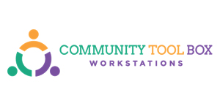

The Year in Review

PROJECT OVERVIEW
Focused on addressing psychosocial aspects of diabetes behavior change in African American communities, the University of Michigan's Department of Medical Education (DME) is an academic department within the University of Michigan Medical School. Located in Ann Arbor, Michigan, the DME is nationally and internationally recognized for their work in the metro-Detroit communities. Through collaborations with other schools and centers at the University, the DME conducts multidisciplinary community-based disparities research.
The Praise Study recruited parish churches for participation. Faith-based interventions have proven effective, although difficult to initiate. The objectives were to examine the effectiveness of two novel approaches in addressing diabetes self-management support (DSMS) in church settings, DSMS with parish nurses, and DSMS with parish nurses in combination with peer leaders. For comparison, participants at parish churches received enhanced usual care. Over the course of two years, nine churches were randomly assigned to one of the aforementioned conditions and 12-15 individuals with type 2 diabetes completed 6 weeks of Diabetes Self-Management Education (DSME) followed by 6 months of support group sessions (DSMS). Subsequently, all participants transitioned into 6 months of ongoing support to measure the psychosocial and self-management maintenance effects. Primary goals of this study were to improve A1C levels and diabetes-related distress. Secondary goals were changes in weight, blood pressure, quality of life, and diabetes social support.

Graph
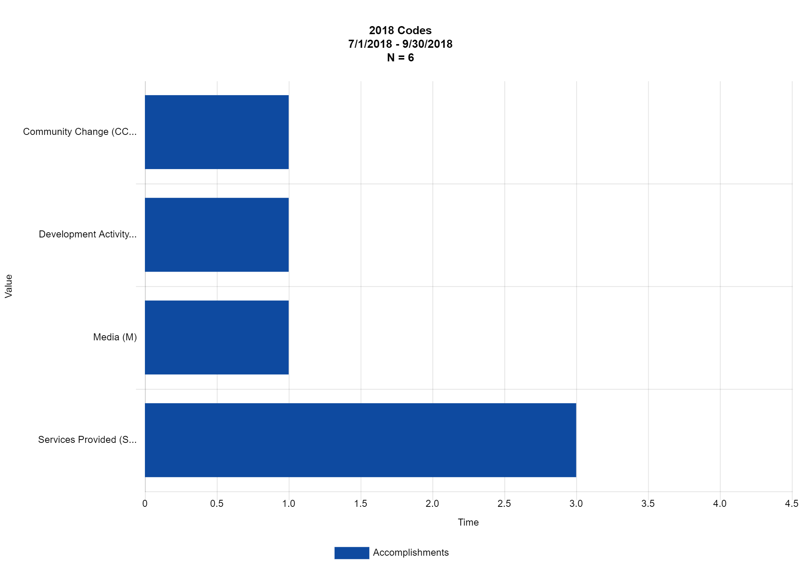
Activity codes for 2018

Date of Activity/Accomplishment: | Description of the Activity /Accomplishment: | Code: | Community Name: | NUMBER OF PEOPLE in attendance:
01/13/2018 | Met with local community leaders to develop action plan. | Services Provided (SP)
07/14/2018 | Christine Connaughton requested and received 25 copies of "Facts about Abuse..." for distribution. |  | Minnesota - Statewide
08/10/2018 | Katherine Brodin of Hennepin COunty Child Care Licensing requested and received 25 copies of "Do Children..." for distribution | Services Provided (SP) | Twin Cities Metropolitan Area (Counties of Anoka, Carver, Dakota, Hennepin, Ramsey, Scott, & Washington)
08/23/2018 | Katherine Brodin of Hennepin COunty Child Care Licensing requested and received 25 copies of "Do Children..." for distribution Test Change |  | Twin Cities Metropolitan Area (Counties of Anoka, Carver, Dakota, Hennepin, Ramsey, Scott, & Washington)
08/26/2018 | Community Event with North View High School students. Gave a presentation and distributed handouts regarding teen pregnancy. | Community Change (CC)
09/07/2018 | Spoke to volunteer group to recruit volunteers to help with our new project. | Development Activity (DA)
09/15/2018 | Attended community event and handed out 150 flyers. | Media (M) | Minnesota - Statewide
09/20/2018 | Attended community event and handed out 100 flyers. | Services Provided (SP) | Minnesota - Statewide
09/23/2018 | Katherine Brodin of Hennepin COunty Child Care Licensing requested and received 25 copies of "Do Children..." for distribution | Services Provided (SP) | Twin Cities Metropolitan Area (Counties of Anoka, Carver, Dakota, Hennepin, Ramsey, Scott, & Washington)

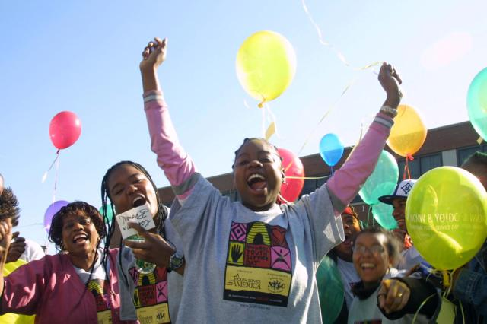
Thanks for all your work!

